A REPORT OF ONE MONTH TRAINING

at

GURU NANAK DEV ENGINEERING COLLEGE, LUDHIANA, PUNJAB

SUBMITTED IN PARTIAL FULFILLMENT OF THE REQUIREMENT FOR THE AWARD

OF THE DEGREE OF

**BACHELOR OF TECHNOLOGY**

(Computer Science and Engineering)



JUNE-JULY ,2024

**SUBMITTED BY:**

NAME: RAHUL KUMAR

UNIVERSITY ROLL NO: 2104162

DEPARTMENT OF COMPUTER SCIENCE AND ENGINEERING

GURU NANAK DEV ENGINEERING COLLEGE LUDHIANA

(An Autonomous College Under UGC ACT)

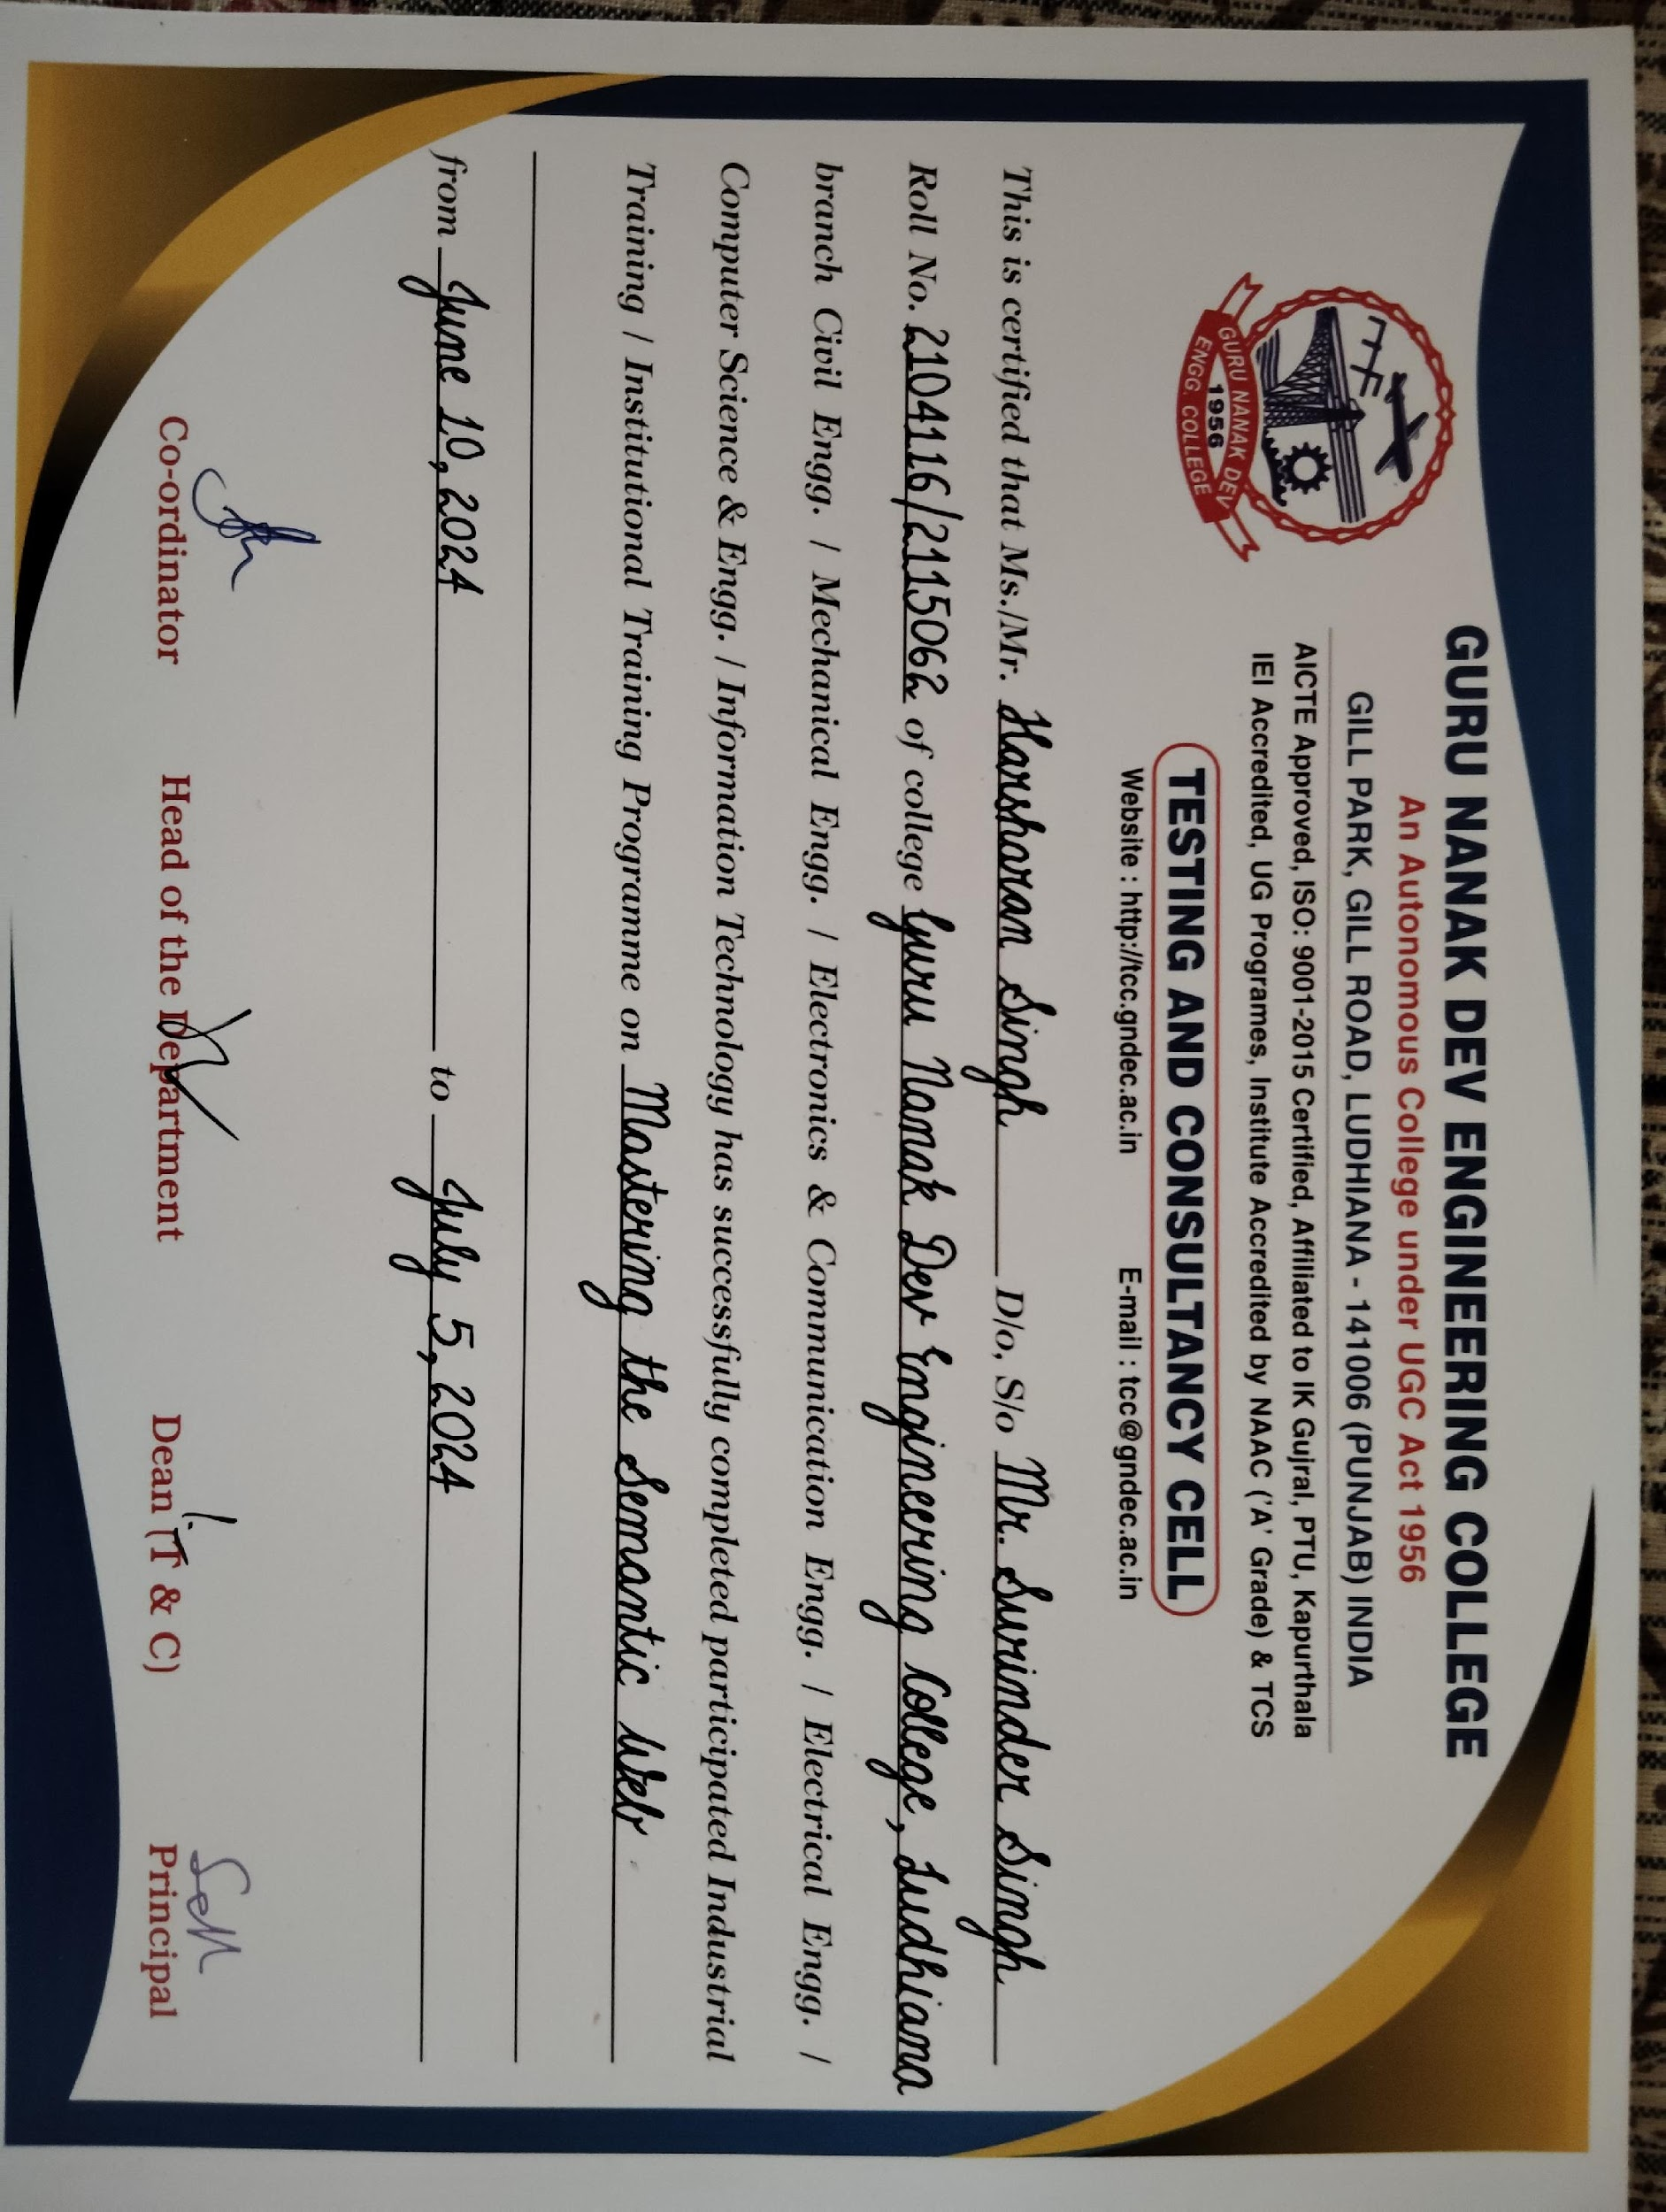

**GURU NANAK DEV ENGINEERING COLLEGE, LUDHIANA**

**CANDIDATE'S DECLARATION**

I “RAHUL KUMAR” hereby declare that I have undertaken one month training from “Guru Nanak Dev Engineering College, Ludhiana, Punjab” during a period from 10 June, 2024 to 5 July,2024 in partial fulfilment of requirements for the award of degree of B.Tech (Computer Science and Engineering) at GURU NANAK DEV ENGINEERING COLLEGE, LUDHIANA. The work which is being presented in the training report submitted to the Department of Computer Science and Engineering at GURU NANAK DEV ENGINEERING COLLEGE, LUDHIANA is an authentic record of training work.

Signature of the Student

The one-month industrial training Viva–Voce Examination of__________________ has been held on ____________ and accepted.

Signature of Internal Examiner Signature of External Examiner

**ABSTRACT**

This training report outlines the training objectives, methodologies, and outcomes of the Four Weeks Summer Training Program on Mastering Semantic Web held at GURU NANAK DEV ENGINEERING COLLEGE, LUDHIANA, PUNJAB. The training program was designed to address specific skill gaps and challenges identified through a thorough needs assessment. Leveraging a blend of instructional strategies, including daily quizzes, weekly assignments, and hands-on exercises, the training aimed to cater to diverse learning preferences and engage participants actively throughout the process. The training session provided a comprehensive exploration of both web technology and the Semantic Web.

In the context of web development, the training covered fundamental Python concepts in the first phase, including Data Structures (Lists, Tuples, Dictionaries, and Sets), Loops and Control Structures, and Functions. Additionally, participants were introduced to popular Python libraries and essential web development technologies such as HTML, CSS, and JavaScript.

Moving forward, the training session focused on RDF (Resource Description Framework) and JSON (JavaScript Object Notation), providing participants with a comprehensive understanding of these data formats and their applications in web technologies.

The training concluded with an exploration of advanced Semantic Web tools and technologies such as WebVOWL for visualizing ontologies, SPARQL for querying RDF datasets, and Feusiki for integrating knowledge across different domains.

This structured approach equipped participants with the necessary skills and knowledge to navigate the complexities of web technology and leverage Semantic Web concepts effectively in their professional endeavours.

**ACKNOWLEDGEMENT**

Firstly, I would like to thank Dr. Sehijpal Singh Khangura (Principal of G.N.D.E.C) and Dr. Kiran Jyoti (HoD of CSE, G.N.D.E.C) for organizing this highly informative four-week industrial training in their Institution. Secondly and most importantly I would like to express my gratitude to Prof. Jaswant Taur (Professor at G.N.D.E.C) coordinator of this Training.

His dedication to share knowledge and expertise was truly inspiring. Throughout the training sessions, his passion for the subject matter shone through, making even the most complex concepts understandable and engaging. His patience in addressing our questions and fostering

an inclusive learning environment created a positive and encouraging atmosphere that allowed us to thrive as trainees. I can't overlook the help and compassion my family and friends gave me throughout this training period. Their support and confidence in my abilities gave me the motivation I needed to seize this chance. As a trainee, I emerge from this experience with insightful knowledge and fresh skills that I can't wait to use in my professional career. This training will have a significant effect outside of the classroom, positively affecting my work and personal development. Once more, I thank sir for being such a superb facilitator and trainer. His commitment has made a lasting impression on my educational experience.

**ABOUT THE INSTITUTE**

Guru Nanak Dev Engineering College (GNDEC), Ludhiana, established in 1956, is one of the oldest and a premier Engineering Institute of India. The Institute is set up on 88 acres of sprawling pristine land along Gill Road (Ludhiana-MalerKotla Highway). The foundation stone of the college was laid by Honourable Dr. Rajendra Prasad Ji, President of India on April 8, 1956. GNDEC is now an autonomous college under UGC Act 1956 [2(f) and 12(B)] and accredited by NAAC with ‘A’ grade The Institution has six Under-Graduate (UG) programmes, thirteen Post-Graduate (PG) programmes, besides being a QIP centre for Ph.D.

GNDEC remains overall sports champion of IKG Punjab Technical University. IKGPTU declared GNDEC Best Engineering college in 2011 and 2012 & 2014 for excellent placements amongst all its affiliated colleges. There is one N.C.C. Company in the institution attached with 3 Pb., Bn N.C.C. (Boy Cadets = 79, Girl Cadets = 27, total of 106 Cadets. Three and a half units of N.S.S. having a total of 350 volunteers have been allotted by IKGPTU to provide opportunities to the students for Social Services in various fields like blood donation, plantation, cleanliness etc. However, a total of more than 1000 volunteers are enrolled in NSS in the College each academic year. FM Radio Station has been established after sanction by Govt. of India for educating the public. The College has been ranked consistently within the first 50 engineering colleges of the country which includes IITs and NITs by different independent national agencies like India Today, Outlook, CSR, Star TV etc. since 2006. The College is in the Rank Band of 200-250 in NIRF Ranking 2021. The department of Computer Science & Engineering (NBA Accredited) was established in 1997. Department is currently offering undergraduate and postgraduate programs with an intake of 240 and 18 respectively. Ph.D. programmes are also being offered in the department.

**LIST OF FIGURES**

*Figure 1.1 Website developed using CSS and HTML*

*Figure 1.2 Website developed with float effect*

*Figure 1.3 Example of a turtle file*

*Figure 1.4 Example of an OWL structure*

*Figure 1.5 Example of an OWL structure2*

*Figure 1.6 Apache Jena Fuseki*

*Figure 1.7 Using WAVE Extension*

*Figure 1.8 Using WebVOWL*

*Figure 2.1 Simple HTML website*

*Figure 2.2 Travel Page Website*

*Figure 3.1 Home Page*

**LIST OF TABLES AND GRAPHS**

*Table 1.1: Web Development Concepts*

*Table 1.2: Semantic Web Concepts*

**Definitions, Acronyms and Abbreviations**

* **FeusiKI**: FeusikI is a knowledge integration platform that facilitates the integration of heterogeneous data sources into a unified knowledge base. It helps in linking and merging data from various domains to create a coherent and comprehensive knowledge representation.
* **JSON (JavaScript Object Notation)**: JSON is a lightweight data-interchange format that is easy for humans to read and write and easy for machines to parse and generate.
* **OWL (Web Ontology Language)**: OWL is a language used to define ontologies, which are formal descriptions of concepts, relationships, and constraints within a domain. It allows for richer and more complex modelling compared to RDF alone.
* **RDF (Resource Description Framework)**: RDF is a framework for representing information about resources on the web. It provides a structured way to describe relationships between resources using triples (subject-predicate-object statements).
* **Semantic Web**: The Semantic Web refers to an extension of the World Wide Web where information is given well-defined meaning, enabling computers and people to work together more effectively.
* **SPARQL (SPARQL Protocol and RDF Query Language)**: SPARQL is a query language for RDF data. It allows querying and manipulating RDF datasets using graph patterns, making it essential for retrieving specific information from Semantic Web data sources.
* XML **(eXtensible Markup Language)**: XML is a markup language that defines a set of rules for encoding documents in a format that is both human-readable and machine-readable.

**CONTENTS**

**Topic Page No.**

***Certificate by Company/Industry/Institute 2***

***Candidate’s Declaration 3***

***Abstract 4***

***Acknowledgement 5***

***About the Institute 6***

***List of Figures 7***

***List of Tables 8***

***Definitions, Acronyms and Abbreviations 9***

**CHAPTER 1 INTRODUCTION 11-30**

1.1 Importance of HTML and CSS 11-16

1.2 Introduction to Semantic Web 16-19 1.3 Use of RDF and Semantic Graphs 19-23 1.4 Tools Learnt 24-30

**CHAPTER 2 TRAINING WORK UNDERTAKEN 31-45**

2.1 Learning HTML and CSS 31-35

2.2 Introduction to RDF, JSON and XML 36-37

2.3 Introduction to SPARQL / Apache Jena Fuseki 37-43

**CHAPTER 3 RESULTS AND DISCUSSION 44**

3.1 Skills Developed 44

**CHAPTER 4 CONCLUSION AND FUTURE SCOPE 45-48**

4.1 Conclusion 45

4.2 Future Scope 46

REFERENCES 47

**CHAPTER 1 INTRODUCTION**

**1.1 Importance of HTML and CSS**

The exploration of HTML and CSS began with an insightful look into their pivotal roles in web development and the essential syntax of each language. HTML, or Hypertext Markup Language, forms the backbone of web content, structuring and defining elements on a webpage. CSS, or Cascading Style Sheets, is crucial for styling these HTML elements, enhancing visual appeal and user experience. Together, HTML and CSS are fundamental in creating and designing web pages, making them indispensable for web developers.

A strong emphasis was placed on comprehending the structure of HTML webpages, an essential foundation for effective web page organization. Key components of an HTML document—headers, footers, main content areas, and sidebars—were thoroughly explained. These elements are vital for creating a well-structured and user-friendly webpage. Headers typically contain the website's logo, navigation menus, and other introductory content. Footers often include contact information, links to privacy policies, and additional navigation aids. The main content area is where the primary information is displayed, and sidebars can offer supplementary navigation, advertisements, or related content. Understanding how to effectively structure these components helps in designing a webpage that is both aesthetically pleasing and easy to navigate.

Website performance optimization was another crucial topic covered, highlighting the importance of website performance and its direct impact on user engagement. A slow website can significantly deter user experience, leading to a decline in user retention. Techniques such as code optimization and streamlining HTTP requests were emphasized as essential strategies to mitigate this issue and ensure an optimal user experience. Code optimization involves writing efficient code, minimizing the use of large libraries, and ensuring that the code is clean and concise. Streamlining HTTP requests, such as reducing the number of requests by combining files and using caching strategies, can significantly enhance website loading times. Tools and techniques like lazy loading for images, using content delivery networks (CDNs), and optimizing media files were also discussed to improve website performance.

An illuminating overview of blockchain technology showcased its decentralized nature and transformative potential. Blockchain, a distributed ledger technology, ensures secure and transparent transactions without the need for a central authority. This decentralization is pivotal for various applications, including cryptocurrencies, supply chain management, and digital identity verification. The discussion covered how blockchain technology can revolutionize traditional systems by offering enhanced security, reduced costs, and increased efficiency. Basic functioning of blockchain, including concepts like blocks, chains, consensus mechanisms, and smart contracts, was explained. Real-world applications and prospects of blockchain technology were explored, emphasizing its potential to transform industries and create new opportunities.

The concept of Web 3.0 was explored in depth, providing insights into its profound implications for the future of the web. Web 3.0, often referred to as the "Semantic Web," aims to make web content more meaningful and understandable to machines. Unlike its predecessors, Web 3.0 focuses on data interoperability, decentralization, and enhanced user interaction. The role of the Semantic Web in imbuing web content with deeper meaning, facilitating machine understanding, was examined. This involves using metadata, ontologies, and linked data to create a web of interconnected information. Web 3.0 can enhance search capabilities, improve data integration, and enable more intelligent and personalized web experiences.

Engaging discussions centred around leveraging Point of Sale (POS) applications within web development, offering valuable insights into their integration across diverse industries such as retail and e-commerce.

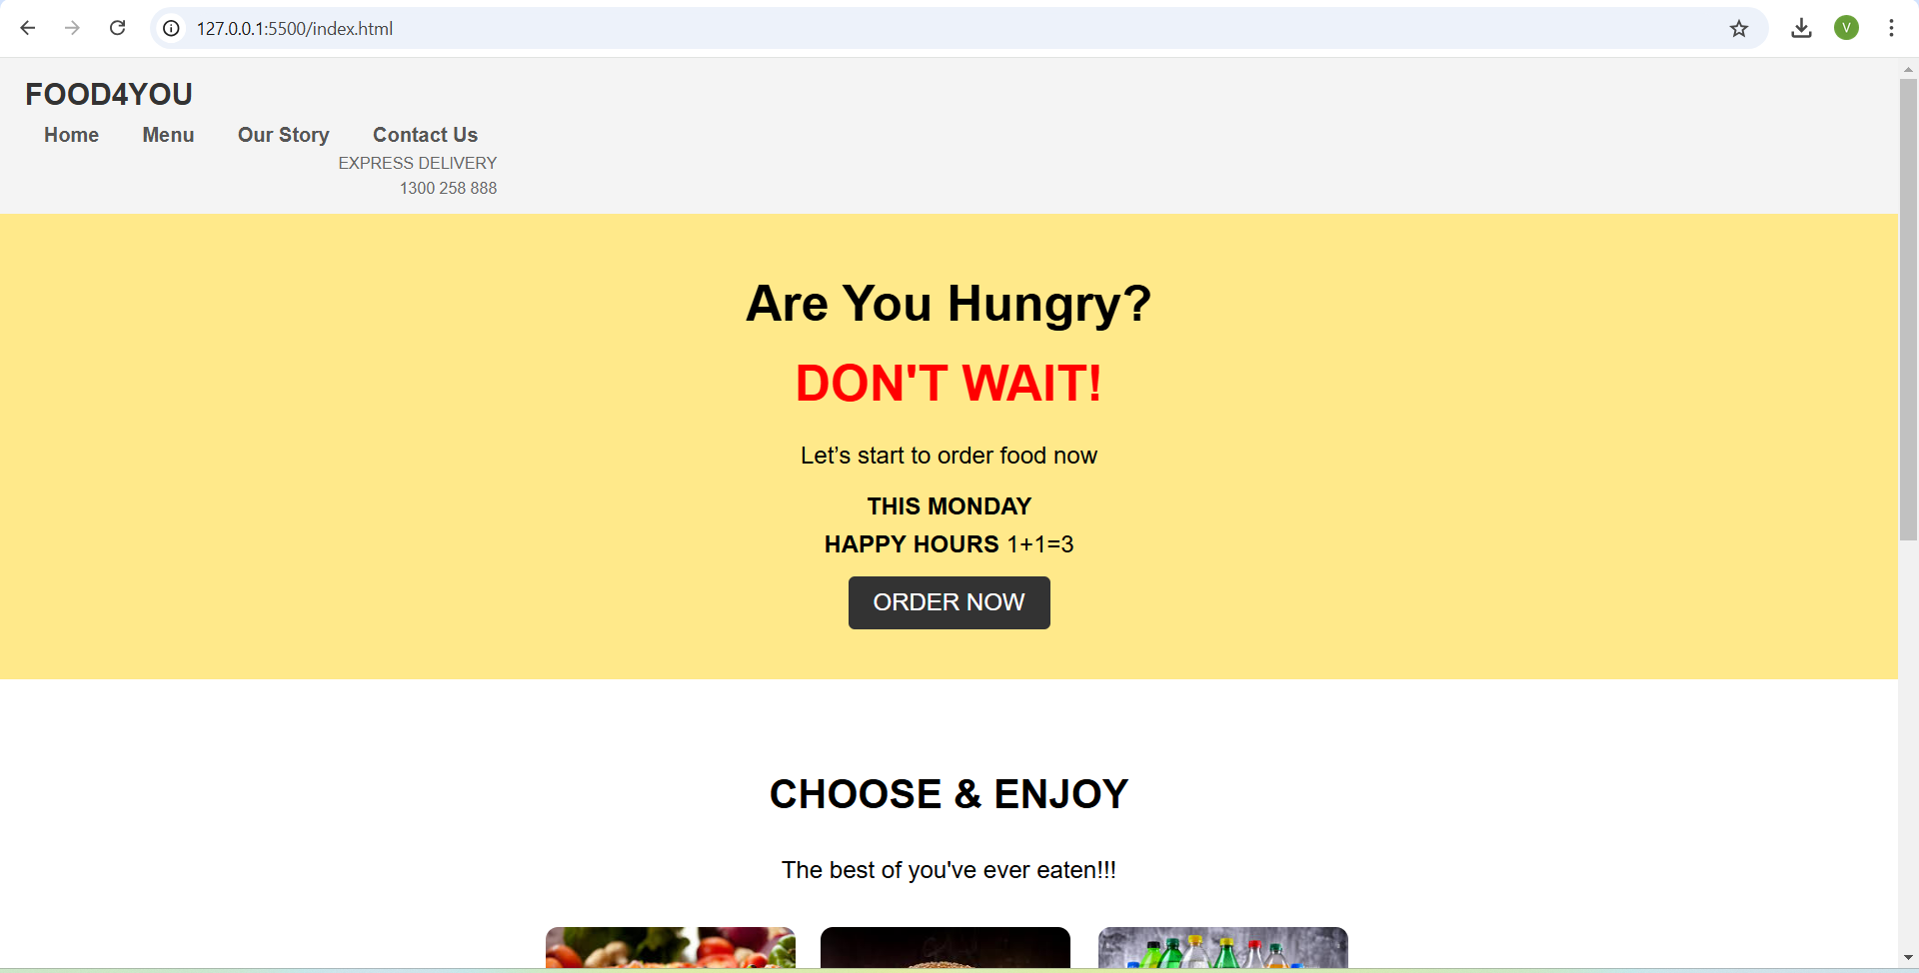

*Figure 1.1 Website developed using CSS and HTML*

POS applications are essential for managing sales transactions, inventory, and customer interactions in real-time. The exploration included how web-based POS systems can streamline business operations, improve customer service, and provide valuable data analytics for better decision-making. Key features of POS systems, such as inventory management, sales reporting, and customer relationship management (CRM), were outlined. The integration of POS applications with e-commerce platforms was also discussed, highlighting how businesses can create seamless and efficient shopping experiences for their customers.

A comprehensive overview of SEO techniques was provided, equipping participants with strategies to enhance website visibility and search engine rankings, thereby maximizing online presence. SEO, or Search Engine Optimization, involves optimizing web content to improve its visibility on search engines like Google. Various aspects of SEO, including keyword research, on-page optimization, and off-page strategies were covered. The importance of using relevant keywords, optimizing meta tags, creating high-quality content, and building backlinks was emphasized. The role of technical SEO, such as improving site speed, mobile-friendliness, and secure connections (HTTPS), was also highlighted. Practical tips and tools for monitoring and improving SEO performance were shared, enabling participants to implement effective SEO strategies for their websites.

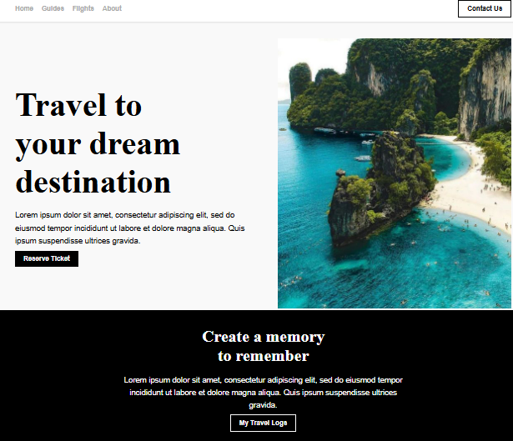

*Figure 1.2 Website developed with float effect*

The learning experience concluded with hands-on exercises in writing basic HTML code, fostering the practical application of theoretical concepts. Attendees practiced using essential HTML tags such as <img>, <table>, <form>, <legend>, <header>, and <p>. These exercises aimed to reinforce the knowledge gained and provide participants with the confidence to create and structure HTML documents effectively. Figures 1.1 and 1.2 depict the websites created during training.

The exploration of CSS covered the different types of CSS—inline, internal, and external—each with its own use cases and advantages. Inline CSS is directly written within the HTML tags using the style attribute, providing a quick and straightforward way to apply styles to individual elements. For example, <p style="color: blue;">This is a blue paragraph. </p> demonstrates how inline CSS can change the colour of a paragraph. Internal CSS is written within the <style> tag in the <head> section of an HTML document. This method is useful for applying styles to a single HTML document, allowing for more organized and manageable code compared to inline CSS. External CSS, stored in a separate .css file and linked to the HTML document using the <link> tag, offers several benefits such as separation of concerns, reusability, efficiency, and consistency.

The advantages of using external CSS were emphasized, highlighting its role in modern web development practices. By keeping HTML content separate from design, external CSS leads to cleaner and more maintainable code. A single external CSS file can be reused across multiple HTML documents, reducing redundancy and ensuring a consistent look and feel across different pages of a website. Additionally, external CSS can reduce the amount of code in individual HTML files, speeding up loading times and making the site easier to manage.

CSS rules for IDs and classes were also covered, essential for applying styles to HTML elements effectively. IDs are unique identifiers that should be used only once within an HTML document. An HTML element cannot have multiple IDs, ensuring each ID is unique. For example, <div id="uniqueID"></div> demonstrates how an ID can be assigned to a div element. Classes, on the other hand, are not unique and can be used multiple times within an HTML document. An HTML element can have multiple classes, allowing for more flexible and reusable styling. For example, <div class="class1 class2"></div> shows how multiple classes can be assigned to a single div element to apply combined styles. Practical exercises demonstrated how to apply different CSS styles to div elements using classes and IDs, exploring the use of multiple classes on a single div and understanding the limitations of using multiple IDs on a single element.

This comprehensive and detailed overview of various aspects of web development, from basic HTML and CSS to advanced topics like blockchain and Web 3.0, provided valuable insights and hands-on experience. The combination of theoretical concepts and practical exercises equipped participants with the skills and knowledge needed to create and optimize modern, dynamic, and user-friendly websites.

**1.2 Introduction to Semantic Web**

Understanding the concept of the Semantic Web is essential for modern web development. The Semantic Web aims to make web data machine-readable, enhancing data findability, shareability, and integration. This concept emphasizes the importance of creating a web where data can be easily accessed and interpreted by machines, enabling more intelligent and efficient data use. One of the fundamental frameworks for the Semantic Web is the Resource Description Framework (RDF). RDF is used to represent information about web resources, ensuring data interoperability across different systems and applications. It achieves this by using a graph form to represent information, where nodes signify entities or resources, edges (predicates/properties) depict relationships between entities, and literals represent values like strings or numbers. This graph structure is intuitive for modelling complex data, making RDF a powerful tool for the Semantic Web.

The basic unit of RDF is the RDF-triple, which consists of three parts: subject, predicate, and object. The subject is the resource being described, the predicate is the property or relationship of the resource, and the object is the value of the property or another related resource. This triplet of the resource, and the object is the value of the property or another related resource. This triplet structure allows for detailed and precise data representation.

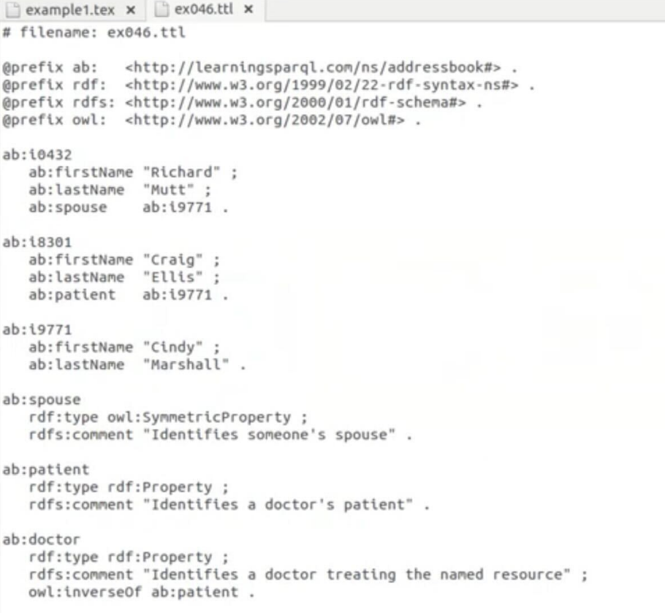

*Figure 1.3 Example of a turtle file*

For practical application, a group exercise was conducted to develop an RDF for online shopping, providing hands-on experience in applying RDF concepts and fostering collaboration and problem-solving skills among participants. In addition to RDF, other data interchange formats are crucial for web development. JSON (JavaScript Object Notation) is a lightweight data interchange format that is easy for humans to read and write and for machines to parse and generate. It is often used for serializing and transmitting structured data over a network, primarily between a server and web applications. On the other hand, XML (eXtensible Markup Language) defines a set of rules for encoding documents in a format that is both human-readable and machine-readable. XML is key in the Semantic Web for defining and transmitting complex data structures. Figure 1.3 depicts a turtle file.

Linked Data is another critical aspect of the Semantic Web, referring to a method of publishing structured data so it can be interlinked and become more useful. It enables data from different sources to be connected and queried as a unified whole, significantly enhancing the value and usability of web data. FOAF (Friend of a Friend) is an ontology used to describe people, their activities, and their relationships to other people and objects, facilitating information sharing and linking across different systems.

Uniform Resource Identifiers (URIs) play a fundamental role in the Web, enabling resources to be identified, accessed, and interacted with. A URI is a string of characters used to identify a resource on the Internet. A specific type of URI is the Uniform Resource Name (URN), which uses a specific scheme to identify a resource by name in a persistent, location-independent manner, ensuring that a resource can be identified even if its location changes.

Understanding the evolution of the Web is also crucial. Web 1.0, the first stage of the World Wide Web, was characterized by static web pages and limited user interaction. Web 2.0 marked the second generation, distinguished by dynamic content, user-generated content, and the rise of social media. Web 3.0, or the Semantic Web, focuses on making web data machine-readable, enabling intelligent agents to understand and respond to complex queries.

A URL (Uniform Resource Locator) is a type of URI that specifies the location of a resource on the Internet, including the protocol used to access the resource and the resource's address. Turtle (Terse RDF Triple Language) is a syntax for writing RDF data in a compact and readable format, used to serialize RDF graphs and is part of the Semantic Web standards. The World Wide Web Consortium (W3C) is an international community that develops open standards to ensure the long-term growth of the Web. It plays a crucial role in the development and standardization of Semantic Web technologies. Additionally, a rewrite engine is a component of web servers that modifies URLs based on defined rules, commonly used to create cleaner, Overall, understanding these concepts and technologies is essential for navigating and contributing to the evolving landscape of the Web. The integration of RDF, JSON, XML, and Linked Data, along with the advancements brought by Web 3.0, paves the way for more intelligent, interconnected, and efficient web systems, enhancing both user experience and data utilization.

*Table 1.1: Web Development Concepts*

|  |  |  |  |
| --- | --- | --- | --- |
| **Concept** | **Definition** | **Applications** | **Tool** |
| HTML | Standard language for structuring web content | Creating web page skeletons | HTML editor |
| CSS | Language used for styling HTML elements | Designing layouts, responsive web designs | CSS Preprocessors |
| Semantic Web | Extension of the web to define data with meaning | Making data machine-readable for better interlinking | RDF, OWL, SPARQL |
| JSON | Lightweight format for data interchange | Data storage and exchange between server and browser | JavaScript, APIs |
| XML | Markup language defining data structure | Storing and transporting data | XML Parsers, Validators |

**1.3 Use of RDF and Semantic Graphs**

The Resource Description Framework (RDF) is a crucial component of the Semantic Web, providing a framework for representing information about web resources. It ensures data interoperability across different systems and applications, enabling diverse systems to understand and use data consistently. RDF represents information in a graph form, where nodes represent entities or resources, edges (predicates/properties) indicate relationships between entities, and literals represent values like strings or numbers. This graph structure is particularly intuitive for modelling complex data. The basic unit of RDF is the RDF-triple, which consists of three parts: subject, predicate, and object. The subject is the resource being described, the predicate is the property or relationship of the resource, and the object is the value of the property or another related resource. A practical exercise involved developing an RDF for online shopping, offering hands-on experience in applying RDF concepts and fostering collaboration and problem-solving skills.

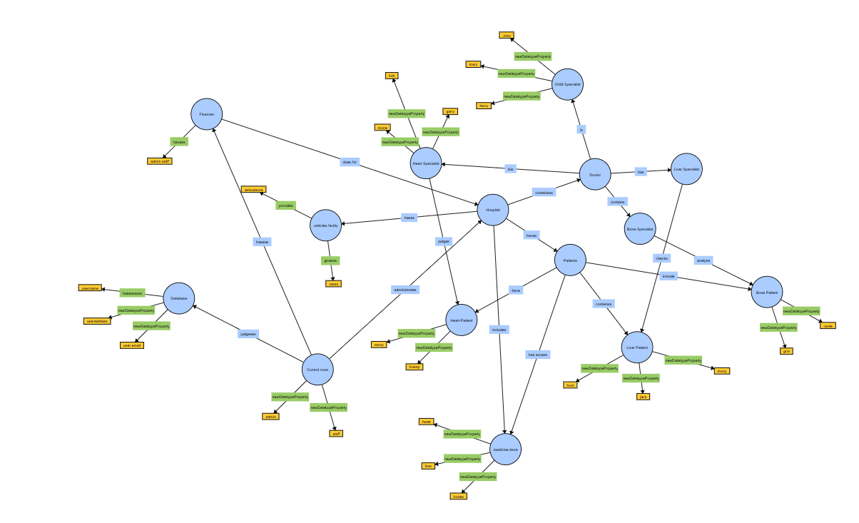

*Figure 1.4 Example of an OWL structure*

In addition to RDF, other data interchange formats are fundamental in web development. JSON (JavaScript Object Notation) is a lightweight data interchange format that is easy for humans to read and write and for machines to parse and generate. It is commonly used for serializing and transmitting structured data over a network, primarily between a server and web applications. XML (eXtensible Markup Language) is another key technology, defining a set of rules for encoding documents in a format that is both human-readable and machine-readable. XML is essential for structuring, storing, and transporting data and plays a pivotal role in the Semantic Web for defining and transmitting complex data structures.

Linked Data refers to a method of publishing structured data so that it can be interlinked and become more useful. It is a critical component of the Semantic Web, allowing data from different sources to be connected and queried as a unified whole. FOAF (Friend of a Friend) is an ontology used to describe people, their activities, and their relationships to other people and objects, facilitating information sharing and linking across different systems. A URI (Uniform Resource Identifier) is a string of characters used to identify a resource on the Internet, enabling resources to be identified, accessed, and interacted with. A specific type of URI is the Uniform Resource Name (URN), which uses a specific scheme to identify a resource by name in a persistent, location-independent manner, ensuring that a resource can be identified even if its location changes.

Understanding the evolution of the Web is also essential. Web 1.0, the first stage of the World Wide Web, was characterized by static web pages and limited user interaction. Web 2.0 marked the second generation, distinguished by dynamic content, user-generated content, and the rise of social media. Web 3.0, or the Semantic Web, focuses on making web data machine-readable, enabling intelligent agents to understand and respond to complex queries. A URL (Uniform Resource Locator) specifies the location of a resource on the Internet, including the protocol used to access the resource and the resource's address. Turtle (Terse RDF Triple Language) is a syntax for writing RDF data in a compact and readable format, used to serialize RDF graphs and is part of the Semantic Web standards.

The World Wide Web Consortium (W3C) is an international community that develops open standards to ensure the long-term growth of the Web. It plays a crucial role in the development and standardization of Semantic Web technologies. A rewrite engine is a component of web servers that modifies URLs based on defined rules, commonly used to create cleaner, more user-friendly URLs and facilitate search engine optimization. In practical applications, relationships among different entities can be defined using RDF and OWL (Web Ontology Language). For example, an RDF Turtle file can describe entities with properties such as firstName, lastName, spouse, and patient, providing meaningful context to the data. Figure 1.4 and 1.5 depicts the OWL structure.

The OWL version used in RDF Turtle files is often denoted by the namespace prefix @prefix

The OWL version used in RDF Turtle files is often denoted by the namespace prefix @prefix owl: <http://www.w3.org/2002/07/owl#>, indicating the use of OWL 2, which provides constructs to create complex ontologies. Non-functional requirements (NFR) for semantic web applications include performance (efficient querying and retrieval of data using RDF stores), security (ensuring data integrity and confidentiality), and reliability (maintaining consistent and accurate relationships among entities). Functional requirements (FR) include data integration (ability to integrate heterogeneous data sources), ontology management (tools for creating, editing, and managing ontologies), reasoning (support for logical inference over the data), and querying (robust querying capabilities using SPARQL).

*Table 1.2: Semantic Web Concepts*

|  |  |  |
| --- | --- | --- |
| **Standard/Protocol** | **Use Case/Description** | **Example Use** |
| RDF (Resource Description Framework) | Describing relationships between resources | Knowledge graphs |
| OWL (Web Ontology Language) | Creating and sharing ontologies for complex data representation | Defining concepts and hierarchies |
| SPARQL | Querying and manipulating RDF data | Querying knowledge bases |
| JSON-LD (JavaScript Object Notation for Linked Data) | Encoding linked data using JSON format | Structured data in web pages |
| RDFS (RDF Schema) | |  | | --- | |  |  |  | | --- | | Providing basic elements for describing ontologies | | Defining properties and classes for RDF data |

The table 1.2 outlines fundamental standards and protocols that form the backbone of semantic web technologies. It highlights five key components: **RDF** (Resource Description Framework), which is used for describing relationships between resources, making it essential for creating knowledge graphs; **OWL** (Web Ontology Language), designed to define and share complex ontologies, allowing for the representation of hierarchical data structures; and **SPARQL**, a query language specifically tailored for extracting and manipulating RDF data, making it ideal for querying knowledge bases. Additionally, **JSON-LD** (JavaScript Object Notation for Linked Data) is used to encode linked data in a lightweight format, commonly used for adding structured data to web pages. Finally, **RDFS** (RDF Schema) provides the foundational elements for defining classes and properties, enabling better organization of RDF data. Together, these standards enable richer data interlinking and semantic reasoning capabilities on the web.

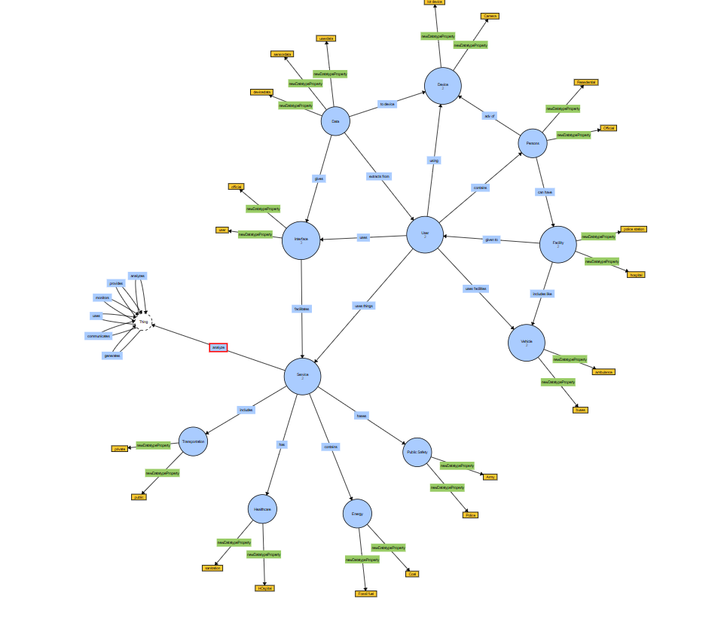

*Figure 1.5 Example of an OWL structure2*

**1.4 Tools Learnt**

We delved into several essential tools integral to web development and semantic web technologies, each offering unique functionalities that contribute to the efficiency, accessibility, and overall quality of web projects. The exploration of these tools provided a comprehensive understanding of their applications and benefits, equipping us with the skills necessary to leverage them effectively in real-world scenarios.

SPARQL, the SPARQL Protocol and RDF Query Language, is a powerful and flexible query language specifically designed for querying and manipulating RDF (Resource Description Framework) data. SPARQL allows for the retrieval and manipulation of data stored in RDF format, making it possible to perform complex queries across diverse datasets. Its capability to query interconnected data across different sources is crucial in the Semantic Web, where data interoperability and integration are key. For instance, with SPARQL, one can query a dataset to find relationships between entities, such as finding all publications authored by a particular researcher across multiple databases. This ability to seamlessly query and integrate data from various sources is invaluable in fields like bioinformatics, where data is often dispersed across different repositories.

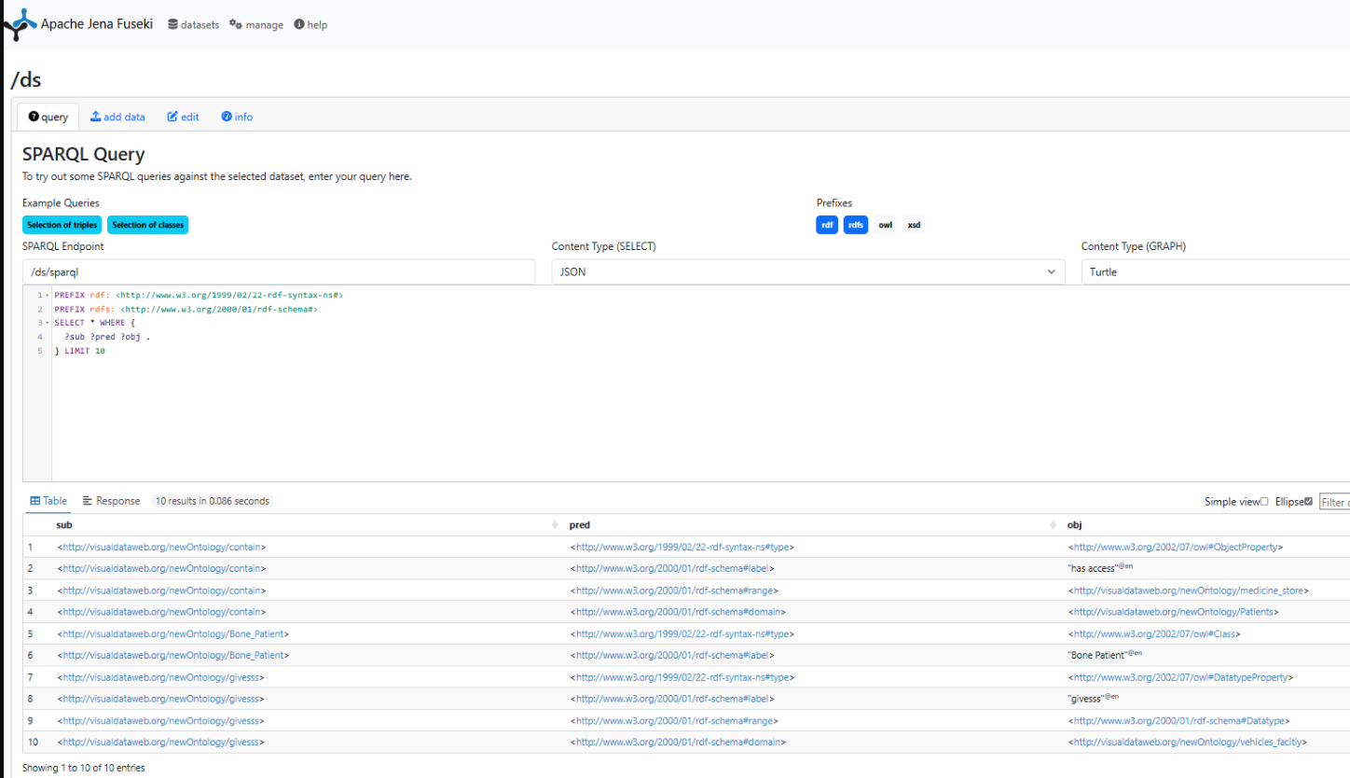

*Figure 1.6 Apache Jena Fuseki*

WebVOWL, a visualization tool for ontologies, enhances our ability to understand and interact with complex RDF data. Ontologies, which define the relationships and categories of data, can become intricate, especially as the amount of data grows. WebVOWL provides a graphical representation of these ontologies, allowing users to visually explore the structure and relationships within the data. This visual approach makes it easier to comprehend complex ontologies, facilitating better analysis and understanding. For example, WebVOWL can be used to visualize the relationships in a large bibliographic database, showing how authors, publications, and research topics interconnect. This visual clarity is particularly beneficial for those who may not be as familiar with the textual representations of RDF data, making it an excellent tool for both education and professional use.

Fuseki, an open-source SPARQL server, plays a crucial role in the management and querying of RDF data. As a server that provides SPARQL endpoints, Fuseki allows for the publication of RDF data on the web, enabling remote querying and data access. This capability is essential for creating web applications that rely on dynamic, query-able data sources. Fuseki supports both query and update operations, providing a robust platform for managing RDF datasets. In practice, Fuseki can be used to host a dataset of environmental data, allowing researchers and the public to run SPARQL queries to retrieve specific information, such as levels of pollutants in a particular area over time. This open access to data encourages transparency and facilitates data-driven decision-making. Figure 1.6 depicts Apache Jena Fuseki.

JIRA, a widely used project management tool, supports agile methodologies and helps teams track and manage software development projects. Its versatility and comprehensive feature set make it an essential tool for ensuring effective collaboration and project delivery. JIRA enables the tracking of tasks, bugs, and project progress through customizable workflows and dashboards. It also integrates with various development tools, providing a seamless experience for software teams. For instance, in a web development project, JIRA can be used to create and manage tasks for different team members, track the progress of each task, and ensure that all aspects of the project are completed on time. Its ability to facilitate communication and coordination among team members is crucial for the successful delivery of complex projects.

In addition to these core tools, several browser extensions significantly enhance the web development process by providing accessibility, performance, and SEO audits. WAVE (Web Accessibility Evaluation Tool) is an extension that evaluates the accessibility of web pages. It helps developers ensure that their websites comply with accessibility standards, such as the Web Content Accessibility Guidelines (WCAG). WAVE provides visual feedback about the accessibility of a webpage, identifying areas that need improvement to make the site more accessible to users with disabilities. For example, WAVE can highlight missing alt text for images or insufficient colour contrast, helping developers create more inclusive web experiences. Figure 1.7 depicts the performance by WAVE on a website created during training.

Lighthouse, an open-source, automated tool, provides comprehensive audits for performance, accessibility, progressive web apps, SEO, and best practices. It can be run in Chrome DevTools, from the command line, or as a Node module. Lighthouse generates detailed reports on various aspects of a webpage, offering actionable recommendations for improvement. For instance, it can identify performance bottlenecks, such as large JavaScript files or unoptimized images, and suggest ways to optimize them. By following Lighthouse's recommendations, developers can enhance the user experience, ensuring faster load times and better accessibility, which in turn can improve search engine rankings and user engagement.

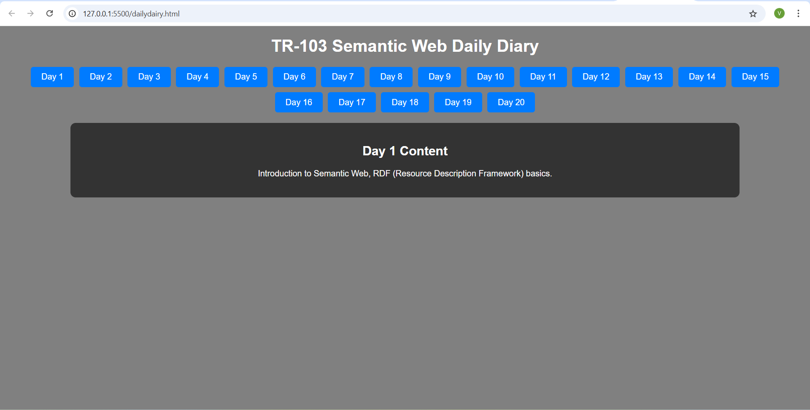

*Figure 1.7 Using WAVE Extension*

Moreover, understanding the broader context of these tools in the evolution of the web is essential. Web 1.0, the first stage of the World Wide Web, was characterized by static web pages with limited user interaction. Web 2.0 marked a significant shift towards dynamic content, user-generated content, and the rise of social media platforms, enabling greater user participation and collaboration. Web 3.0, also known as the Semantic Web, aims to make web data machine-readable, allowing intelligent agents to understand and respond to complex queries. This evolution focuses on data integration, interoperability, and the creation of a more intelligent web where data can be seamlessly connected and queried.

To facilitate this interconnected web, various standards and technologies have been developed. RDF, as mentioned earlier, plays a pivotal role in representing information about web resources. Linked Data, a method of publishing structured data so that it can be interlinked and become more useful, is another key component of the Semantic Web. It allows data from different sources to be connected and queried as a unified whole, enhancing data findability, shareability, and integration. FOAF (Friend of a Friend) is an ontology used to describe people, their activities, and their relationships to other people and objects, enabling information to be shared and linked across different systems. URIs (Uniform Resource Identifiers) and URLs (Uniform Resource Locators) are fundamental components of the web, enabling resources to be identified, accessed, and interacted with.

Furthermore, a Content Delivery Network (CDN) is a distributed network of servers that deliver web content to users based on their geographic location. CDNs reduce latency by serving content closer to the user, improve load times for websites, enhance security through DDoS protection and secure data transfer, and provide scalability to handle large amounts of traffic. This infrastructure is crucial for ensuring a fast and reliable user experience, particularly for global audiences. Figure 1.8 depicts the WebVOWL infrastructure.

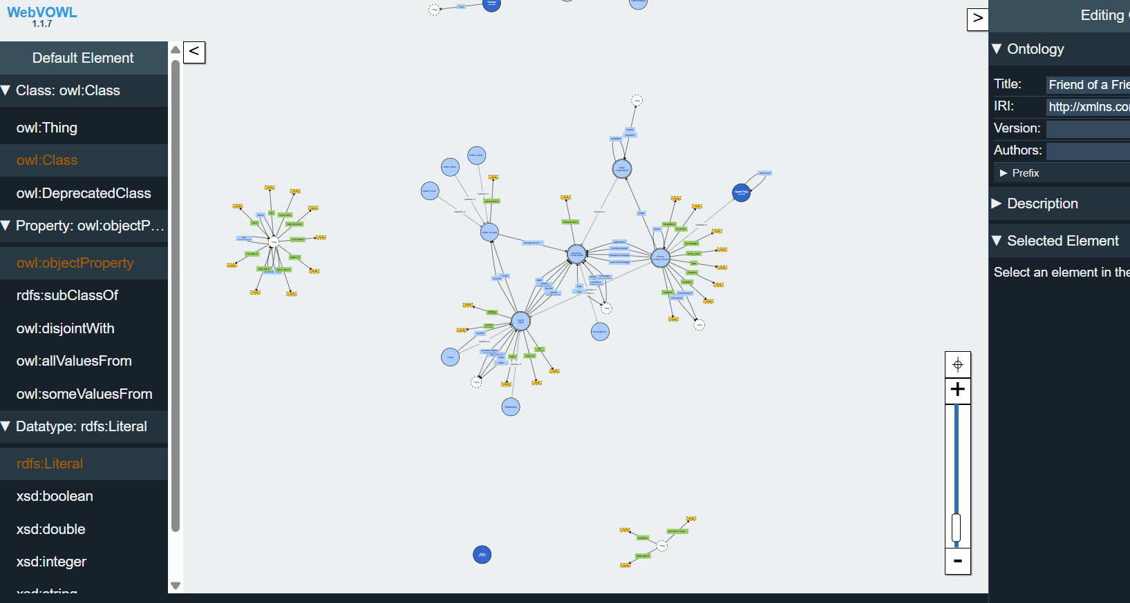

*Figure 1.8 Using WebVOWL*

Non-functional requirements (NFR) and functional requirements (FR) are also critical in the development of semantic web applications. NFRs include performance, security, and reliability. Performance involves efficient querying and retrieval of data using RDF stores and optimized ontology reasoning to ensure quick response times. Security encompasses ensuring data integrity and confidentiality, employing authentication and authorization mechanisms to control access to RDF data. Reliability focuses on maintaining consistent and accurate relationships among entities and ensuring robustness in data processing and ontology management. Functional requirements (FR) include data integration, ontology management, reasoning, and querying capabilities. These requirements ensure that semantic web applications can integrate heterogeneous data sources, provide tools for creating and managing ontologies, support logical inference over the data, and offer robust querying capabilities using SPARQL.

Lastly, tools like Google Pagespeed Insights, GTmetrix, and Lighthouse play a crucial role in optimizing web performance. Google Page Speed Insights analyses the performance of web pages, offering insights and suggestions for improving page speed and overall performance. It evaluates load time, resource optimization, and best practices for web performance. GTmetrix provides a detailed analysis of a website's performance, using metrics and recommendations from Google Page Speed and Yahoo! YSlow. It offers page load details, recommendations for improving speed, and performance scores. Lighthouse provides comprehensive audits for performance, accessibility, progressive web apps, SEO, and best practices, helping developers optimize their web pages for better performance and user engagement.

In conclusion, the exploration of tools such as SPARQL, WebVOWL, Fuseki, JIRA, and extensions like WAVE and Lighthouse provided a deep understanding of their applications and benefits. These tools collectively enhance the efficiency, accessibility, and overall quality of web projects, equipping us with the skills necessary to leverage them effectively.

**CHAPTER 2 TRAINING WORK UNDERTAKEN**

**2.1 Learning HTML, CSS**

We delved deeply into HTML (Hypertext Markup Language) and CSS (Cascading Style Sheets), two foundational technologies crucial for creating and styling web pages. This immersive learning experience offered attendees a thorough understanding of both languages, covering their syntax, structure, and practical applications in building efficient, visually appealing, and well-organized websites.

We began with a detailed study of HTML, the backbone of web content. HTML provides the basic structure of websites, allowing developers to define and organize content through various elements and tags. Essential HTML components such as headers, footers, main content areas, and sidebars were emphasized, illustrating how these elements contribute to effective webpage organization. We examined the role of different HTML tags, understanding their functions and appropriate usage. Tags like <img> for images, <table> for tabular data, <form> for user inputs, <legend> for form descriptions, <header> for introductory content, and <p> for paragraphs were explored in depth. Hands-on exercises reinforced these concepts, enabling participants to practice writing basic HTML code and gaining confidence in creating structured web pages.

The importance of semantic HTML was a significant focus, highlighting how using the correct HTML tags not only improves the accessibility and SEO (Search Engine Optimization) of a website but also makes the code more readable and maintainable. Semantic tags like <article>, <section>, <nav>, and <aside> were discussed, showing how they convey meaningful information about the content they enclose. This practice of using semantic HTML ensures that both browsers and search engines can better understand the structure and content of a web page, ultimately enhancing the user experience and search engine rankings.

Our journey into CSS began with understanding its role in separating content from design, which Our journey into CSS began with understanding its role in separating content from design, which is critical for maintaining clean, readable, and maintainable code. We explored the three types of CSS: inline, internal, and external. Inline CSS involves applying styles directly within HTML tags using the style attribute, which is useful for quick, single-use styles. Internal CSS is written within the <style> tag in the <head> section of an HTML document, allowing for centralized control of styles within a single page. External CSS, stored in separate .css files, is linked to HTML documents using the <link> tag. This approach promotes separation of concerns, enabling developers to reuse a single CSS file across multiple pages, reduce redundancy, and ensure consistency across a website.

The advantages of using external CSS were particularly emphasized. By keeping HTML content separate from design, external CSS leads to cleaner and more maintainable code. It enhances reusability, as a single CSS file can style multiple HTML documents, reducing redundancy and streamlining updates. Additionally, external CSS improves efficiency by reducing the amount of code in individual HTML files, which can speed up loading times and make the site easier to manage. Ensuring consistency across different pages of a website is another key benefit, as it guarantees a unified look and feel.

We delved into CSS selectors and properties, learning how to target HTML elements and apply various styles. Understanding the specificity and cascade principles of CSS allowed us to write more efficient and predictable stylesheets. We practiced using IDs and classes to style elements, recognizing that IDs should be unique within an HTML document and used for single, specific elements, while classes can be reused across multiple elements. This distinction is crucial for applying styles effectively and maintaining the integrity of the HTML structure.

The practical application of CSS was reinforced through hands-on exercises, where we practiced applying different styles to div elements using classes and IDs. We explored how to use multiple classes on a single div to apply combined styles and demonstrated the limitations of using multiple IDs on a single element, understanding why it's not allowed in HTML and CSS. This practical approach helped solidify our understanding of CSS syntax and its application in real-world scenarios.

Another critical aspect of our learning was website performance optimization. We discussed the vital importance of website performance and its direct impact on user engagement. Through insightful discussions, it was highlighted how a slow website can significantly deter user experience and lead to a decline in user retention. Techniques such as code optimization, reducing file sizes, and streamlining HTTP requests were presented as essential strategies to mitigate performance issues and ensure an optimal user experience. Tools like Google Pagespeed Insights, GTmetrix, and Lighthouse were introduced, providing practical methods to analyse and improve website performance. These tools offer valuable insights and recommendations for optimizing page speed, resource utilization, and overall performance.

In addition to performance optimization, we explored advanced CSS techniques such as responsive design and CSS frameworks. Responsive design, achieved through media queries and flexible layouts, ensures that websites are accessible and functional across various devices and screen sizes. We practiced creating responsive layouts using CSS Grid and Flexbox, understanding how these modern layout modules provide powerful and flexible ways to design complex web layouts. CSS frameworks like Bootstrap were introduced, demonstrating how they can accelerate development by providing pre-designed components and styles, ensuring consistency and responsiveness.

Our exploration also touched on the dynamic aspects of web development, introducing attendees to the concept of dynamic websites. We discussed how server-side programming languages like PHP, Python, and Node.js can generate dynamic content, enhancing user engagement and interaction. This understanding of dynamic website development methodologies provided a foundation for further exploration into full-stack web development. Moreover, the integration of Point of Sale (POS) applications within web development was examined, offering valuable insights into their application across diverse industries such as retail and e-commerce. Engaging discussions centred around leveraging POS systems to streamline business operations, enhance customer experiences, and integrate with web-based platforms for real-time data processing and management. Search Engine Optimization (SEO) techniques were also a crucial part of our learning, equipping participants with strategies to enhance website visibility and search engine rankings. We explored best practices for on-page SEO, such as optimizing meta tags, using semantic HTML, improving page load times, and creating high-quality, relevant content. Understanding the principles of SEO is vital for maximizing online presence and driving organic traffic to websites.To culminate our learning experience, we engaged in hands-on exercises, writing basic HTML code and applying CSS styles. These exercises encompassed essential tags and styles, fostering practical application of theoretical concepts. To culminate our learning experience, we engaged in hands-on exercises, writing basic HTML code and applying CSS styles. These exercises

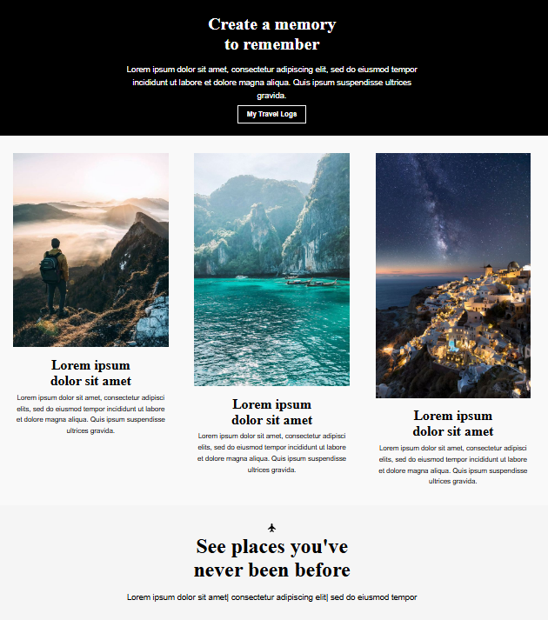

practical application of theoretical concepts. To culminate our learning experience, we engaged in hands-on exercises, writing basic HTML code and applying CSS styles. These exercises encompassed essential tags and styles, fostering practical application of theoretical concepts. By creating simple web pages and progressively enhancing them with CSS, we built a solid foundation for further exploration and development in web technologies.

**2.2 Introduction to RDF, JSON, XML**

During our exploration of web technologies, we examined RDF (Resource Description Framework), JSON (JavaScript Object Notation), and XML (extensible Markup Language), appreciating their critical roles in data representation, interchange, and integration across diverse web applications. These technologies form the backbone of the Semantic Web, enabling structured data to be shared, linked, and utilized coherently.

RDF plays a fundamental role in representing information about web resources. It allows data to be described in a machine-readable and semantically rich format using a graph-based data model. In this model, nodes represent entities or resources, edges (predicates/properties) represent relationships between entities, and literals represent values such as strings or numbers. This graph structure is intuitive for modelling complex data and relationships, making RDF particularly powerful for Semantic Web applications.

A core component of RDF is the RDF-triple, which consists of three parts: Subject, Predicate, and Object. The Subject is the resource being described, the Predicate is the property or relationship of the resource, and the Object is the value of the property or another related resource. This structure allows for precise and flexible data representation, facilitating interoperability across different systems and applications. For instance, in an RDF graph describing an online shopping scenario, an RDF-triple might represent a relationship where a "Product" (Subject) "has Price" (Predicate) "29.99" (Object).

Engaging in a group exercise to develop an RDF model for an online shopping platform provided practical application of RDF concepts, reinforcing theoretical knowledge through hands-on experience. This involved creating RDF triples to describe various entities such as products, customers, and orders, and their interrelationships, effectively modelling real-world scenarios.

JSON, a lightweight data interchange format, is widely used for serializing and transmitting structured data over a network, primarily between a server and web applications. Its simplicity and efficiency have made it the de facto standard for data interchange in modern web development. JSON structures data using key-value pairs or an ordered list of values, making it highly versatile and easy to use. For example, a JSON object representing a product might look like this:

json

Copy code

{

"productId": "12345",

"productName": "Wireless Mouse",

"price": 29.99,

"inStock": true

}

This straightforward representation allows developers to quickly parse and manipulate data, facilitating seamless communication between client and server. JSON's compatibility with JavaScript and its widespread support across various programming languages have contributed to its popularity in web APIs and services.

XML, a markup language that defines a set of rules for encoding documents in a format that is both human-readable and machine-readable, is used to structure, store, and transport data. It plays a key role in the Semantic Web for defining and transmitting complex data structures. Unlike JSON, which is primarily focused on data interchange, XML is often used for document-centric data storage and transmission. XML documents are structured hierarchically, with nested elements that define the relationships between different pieces of data. For example, an XML representation of a product might look like this:

xml

Copy code

<Product>

<ProductId>12345</ProductId>

<ProductName>Wireless Mouse</ProductName>

<Price>29.99</Price>

<InStock>true</InStock>

</Product>

The hierarchical nature of XML allows for the creation of complex data models with nested relationships, making it suitable for applications where data needs to be richly described and validated. XML schemas can define the structure and data types of XML documents, ensuring consistency and interoperability.

In the context of Linked Data and the Semantic Web, RDF, JSON, and XML are essential. Linked Data refers to a method of publishing structured data so that it can be interlinked and become more useful. This approach enables data from different sources to be connected and queried as a unified whole, leveraging RDF for data modelling and XML/JSON for data interchange.

FOAF (Friend of a Friend) is an ontology used to describe people, their activities, and their relationships to other people and objects. It is a part of the Semantic Web and allows information to be shared and linked across different systems. FOAF uses RDF to define relationships such as "knows" between people, facilitating the creation of interconnected data about individuals and their social networks.

URIs (Uniform Resource Identifiers) and URNs (Uniform Resource Names) are crucial in the Semantic Web. A URI is a string of characters used to identify a resource on the Internet, while a URN is a type of URI that uses a specific scheme to identify a resource by name in a persistent, location-independent manner. URNs ensure that a resource can be identified even if its location changes, contributing to the robustness and reliability of web data.

Web technologies continue to evolve, and understanding these fundamental concepts is essential for developing modern, dynamic web applications. By leveraging RDF, JSON, and XML, developers can create rich, interconnected data models that enhance the functionality and interoperability of web systems, paving the way for the future of the Semantic Web.

**2.3 Introduction to SPARQL / APACHE JENA FUSEKI**

To begin working with Apache Jena Fuseki, the initial step was to download the software. This was accomplished by visiting the official Apache Jena website at jena.apache.org. Once there, I navigated to the download section specifically for Fuseki and selected the latest stable release version for optimal performance and compatibility. After choosing the desired version, I downloaded the corresponding zip archive suitable for my operating system and extracted the files to a preferred directory on my system.

Ensuring that my system met the Java version requirements was crucial for the smooth functioning of Apache Jena Fuseki. The software required Java 8 or later versions. To verify if Java was installed on my system, I opened a terminal and ran the command java -version. If Java had not been installed or was an outdated version, I would have downloaded and installed the latest Java Development Kit (JDK) from the Oracle website or used an open-source alternative like OpenJDK.

To upload data over Apache Jena Fuseki, I started by navigating to the directory where Fuseki was extracted and ran the server using the command. /fuseki-server on Linux. After starting the Fuseki server, I accessed the Fuseki user interface by opening a web browser and going to http://localhost:3030. To create a dataset, I clicked on "Datasets," then "Add new dataset," entered a name, and selected the dataset type (e.g., in-memory or TDB). To upload RDF data, I selected the newly created dataset, went to the "Upload" tab, chose the RDF data file from my local machine, and clicked "Upload" to load the data into the dataset.

When it came to writing and executing a query, I selected the dataset I wanted to query from the Fuseki interface and navigated to the "Query" tab. Using SPARQL, I wrote queries to extract information from the RDF data. For instance, a query using the prefix foaf to select the names of all persons in the dataset was written as follows:

sparql

Copy code

PREFIX foaf: <http://xmlns.com/foaf/0.1/>

SELECT? name WHERE {

? person a foaf:Person .

? person foaf:name ?name .

After entering the SPARQL query into the query text area, I clicked "Run Query" to execute it and viewed the results in the results pane, which displayed the query output in tabular form.

SPARQL query basics involve constructing statements using various query types, clauses, and solution modifiers. Standard query types include SELECT, CONSTRUCT, ASK, and DESCRIBE. The SELECT query type finds and returns all data that matches specific patterns. CONSTRUCT queries are used to create or transform data based on existing data. ASK queries check for the existence of a certain pattern and return "true" or "false." DESCRIBE queries view the RDF graph describing a particular resource.

Queries may include clauses such as the PREFIX clause, which declares abbreviations for URIs; the FROM clause, which defines datasets or graphs to query; and the WHERE clause, which specifies the query pattern for data matching. Solution modifiers like ORDER BY, OFFSET, LIMIT, GROUP BY, and HAVING further refine query results by sorting, grouping, and filtering data.

For example, a basic SELECT query to retrieve all triples from a dataset is written as:

sparql

Copy code

SELECT ?subject ?predicate ?object

WHERE {

?subject ?predicate ?object.

}

This query retrieves all data in the RDF graph by selecting subject, predicate, and object for each triple.

Another query to retrieve names and ages of individuals would be:

sparql

Copy code

PREFIX ns1: <http://example.org/>

SELECT ?name ?age

WHERE {

? person ns1:name ?name ;

ns1:age ?age .

}

This query uses the ns1 prefix to refer to properties in the http://example.org/ namespace and retrieves the name and age for each individual described in the RDF data.

To filter individuals by age, a query might look like this:

sparql

Copy code

PREFIX ns1: <http://example.org/>

SELECT ?name

WHERE {

?person ns1:name ?name ;

ns1:age ?age .

FILTER(?age > 5)

}

This query retrieves names of individuals older than 5 years using the FILTER clause.

Counting the number of individuals can be achieved with:

sparql

Copy code

PREFIX ns1: <http://example.org/>

SELECT (COUNT(?person) AS ?numberOfIndividuals)

WHERE {

?person ns1:name ?name .

}

This query counts the total number of individuals in the dataset using the COUNT function.

To retrieve individuals with a specific name:

sparql

Copy code

PREFIX ns1: <http://example.org/>

SELECT ?person ?age

WHERE {

?person ns1:name "f" ;

ns1:age ?age .

}

This query selects individuals named "f" and their ages.

For grouping individuals by age and counting each group:

sparql

Copy code

PREFIX ns1: <http://example.org/>

SELECT ?age (COUNT(?person) AS ?count)

WHERE {

?person ns1:age ?age .

}

GROUP BY ?age

This query groups individuals by age and counts the number in each group using the GROUP BY clause.

To retrieve individuals with names starting with a specific letter:

sparql

Copy code

PREFIX ns1: <http://example.org/>

SELECT ?name

WHERE {

?person ns1:name ?name .

FILTER(STRSTARTS(?name, "s"))

}

This query retrieves names of individuals whose names start with "s" using the STRSTARTS function.

Retrieving individuals with ages in a specific range:

sparql

Copy code

PREFIX ns1: <http://example.org/>

SELECT ?name ?age

WHERE {

?person ns1:name ?name ;

ns1:age ?age .

FILTER(?age >= 4 && ?age <= 7)

}

This query selects names and ages of individuals aged between 4 and 7 years inclusive.

To retrieve the youngest individual:

sparql

Copy code

PREFIX ns1: <http://example.org/>

SELECT ?name ?age

WHERE {

?person ns1:name ?name ;

ns1:age ?age .

}

ORDER BY ?age

LIMIT 1

This query retrieves the name and age of the youngest individual by ordering results by age in ascending order and limiting the result to one.

For the oldest individual:

sparql

Copy code

PREFIX ns1: <http://example.org/>

SELECT ?name ?age

WHERE {

?person ns1:name ?name ;

ns1:age ?age .

}

ORDER BY DESC(?age)

LIMIT 1

This query retrieves the name and age of the oldest individual by ordering results by age in descending order and limiting the result to one.

These queries demonstrate how to retrieve, filter, and aggregate data using SPARQL, allowing the extraction of meaningful information from an RDF dataset.

**CHAPTER 3 RESULTS AND DISCUSSION**

* 1. **SKILLS DEVELOPED**

The foundational principles and practical applications of RDF, OWL, and SPARQL, as well as proficiency in using key tools and techniques for data integration and visualization are few skills that were developed during the whole session.

The following are the range of skills developed during session:

1. Understanding of RDF, OWL, and SPARQL standards.
2. Proficiency in creating and querying RDF datasets.
3. Knowledge of ontology modelling and design using OWL.
4. Ability to use semantic web tools like Protégé and Apache Jena.
5. Competence in linking and integrating data from diverse sources.
6. Skills in data visualization and interpretation.
7. Experience with RDF serialization formats (RDF/XML, Turtle, N-Triples).
8. Familiarity with semantic web applications and use cases.
9. Enhanced problem-solving and analytical thinking abilities.
10. Development of user-friendly interfaces for semantic web tools.

A solid understanding of RDF, OWL, and SPARQL standards, which form the foundation of semantic web technologies. Training also includes hands-on experience with semantic web tools like Protégé and Apache Jena, along with the ability to link and integrate data from various sources. Skills in data visualization and interpretation are developed, as well as familiarity with RDF serialization formats such as RDF/XML, Turtle, and N-Triples. In addition to all these **I have also developed pages for my daily report and can be accessed at the following link: TR-103 (**[**https://github-ui-cpu.github.io/Semantic-Web/**](https://github-ui-cpu.github.io/Semantic-Web/)**)**

**CHAPTER 4: CONCLUSION AND FUTURE SCOPE**

* 1. **CONCLUSION**

The training in Semantic Web has been instrumental in equipping participants with a robust foundation in essential concepts and technologies crucial for modern web development and data management. Throughout the program, participants delved into fundamental topics such as RDF (Resource Description Framework), OWL (Web Ontology Language), SPARQL (SPARQL Protocol and RDF Query Language), JSON (JavaScript Object Notation), XML (extensible Markup Language), and advanced tools like FeusiKI. The training sessions provided a structured approach to understanding RDF, which forms the backbone of Semantic Web data representation, enabling participants to grasp how to describe resources and their relationships in a standardized format. OWL, on the other hand, empowered them with the ability to define complex ontologies, enriching their knowledge about conceptual modelling and domain-specific knowledge representation. SPARQL, as the query language for RDF data, was a focal point in enabling participants to retrieve and manipulate Semantic Web data effectively. They learned to construct queries that extract meaningful information from interconnected datasets, enhancing their skills in semantic querying and data integration. The introduction to JSON and XML underscored the importance of data interchange formats in web applications, showcasing their role in transmitting structured data across different platforms and systems. Participants gained hands-on experience in manipulating and validating data using these formats, essential skills for building robust web applications. Moreover, the training emphasized practical applications through tools like FeusiKI, which facilitated the integration of heterogeneous data sources into unified knowledge bases. This capability is crucial for businesses and organizations looking to leverage diverse datasets for enhanced decision-making and knowledge management.

* 1. **FUTURE SCOPE**

Semantic Web technologies are poised to revolutionize data management and web development in the coming years. With increasing volumes of data being generated daily, these technologies offer a robust framework for organizing, linking, and extracting meaningful insights from diverse datasets. Future advancements may see the emergence of more intelligent applications that leverage ontologies and semantic relationships to enhance automation, personalization, and decision-making processes across various sectors. Enhanced interoperability facilitated by RDF, OWL, and JSON will enable seamless integration of data from disparate sources, fuelling innovations in AI-driven knowledge graphs, semantic search engines, and dynamic content delivery systems. Industries are expected to embrace these technologies to drive efficiency, improve data governance, and unlock new opportunities for innovation in areas such as personalized healthcare, smart cities, and predictive analytics. As standards evolve and adoption grows, Semantic Web technologies will continue to play a pivotal role in shaping the digital landscape, facilitating smarter data-driven solutions and transforming how organizations leverage information for strategic advantage.

**REFERENCES:**

1. M. Zolan Vari, M. A. Teixeira, L. Gupta, K. M. Khan, and R. Jain. "Machine learning- based network vulnerability analysis of Industrial Internet of Things,"
2. M. Zolan Vari, M. Teixeira, R. Jain, “Effect of Imbalanced Datasets on Security of Industrial IoT Using Machine Learning”
3. S.Potluri, N. F. Henry and C. Diedrich, “Evaluation of Hybrid Deep Learning Techniques for Ensuring Security in Networked Controlled Systems”.
4. Scikit-learn. [Online], Available: <https://scikit-learn.org/stable/>
5. M.Mantere, M.Sailo and S. Noponen, “Feature Selection for Machine Learning Based Anomaly Detection in Industrial Control System Networks”.2012 IEEE International Conference on Green Computing and Communications, no. Besancon, pp.771-774,2012.
6. [Machine Learning Tutorial (geeksforgeeks.org)](https://www.geeksforgeeks.org/machine-learning/)
7. P. A. A. Resende and A. C. Drummond, “A Survey of Random Forest Based Methods for Intrusion Detection Systems,” ACM Computing Surveys, vol. 51, no. 3, pp. 48:1-48:36, May 2018. DOI: <https://doi.org/10.1145/3178582>.
8. Internet of Things Cyber Attacks Detection using Machine Learning, Jadel Alsamiri1, Khalid Alsubhi2, Faculty of Computing and Information Technology, King Abdulaziz University, Jeddah, KSA
9. M. Panda and M. R. Patra, “Network intrusion detection using naïve bayes,” International journal of computer science and network security, Vol. 7, no. 12, pp. 258–263, 2007.
10. Data Science and its Relationship to Big Data and Data-Driven Decision-Making Foster Provost and Tom Fawcett, Published Online:13 Feb 2013 https://doi.org/10.1089/big.2013.1508
11. [What Is Data Science? Definition, Skills, Applications, Projects, and More (geeksforgeeks.org)](https://www.geeksforgeeks.org/what-is-data-science/)
12. https://www.geeksforgeeks.org/python-programming-language/